 | 26.4 Editors - Properties Editor - View Layer Properties Tab
Table of content
Detailed table of content 1
View Layer 11
View Layer Panel - All Renderers 11
Eevee - Passes panel 12
Cycles - Passes Panel 15
Cycles - Filter Panel 20
Cycles - Override Panel 21
Freestyle Panel 22
Freestyle Line Set Panel 23
Freestyle Strokes Panel 27
Freestyle Modifiers 29
Freestyle Color panel 32
Freestyle Color modifiers 32
Freestyle Alpha panel 36
Freestyle Alpha modifiers 36
Freestyle Thickness panel 41
Freestyle Thickness modifiers 42
Freestyle Geometry 47
Freestyle Geometry Modifiers 47
Freestyle Texture 52
Custom Properties Panel 52

Detailed table of content

Detailed table of content
Detailed table of content 1
View Layer 11
View Layer Panel - All Renderers 11
View Layer Prop 11
View Layer list 11
View Layer edit box 11
Add View Layer 11
New 12
Copy Settings 12
Blank 12
Remove View Layer 12
Use for Rendering 12
Animate Property 12
Render Single Layer 12
Eevee - Passes panel 12
Data subpanel 12
Combined 12
Z 12
Mist 12
Normal 13
Mist subpanel 13
Start 13
Depth 13
Falloff 13
Light subpanel 13
Diffuse 13
Light 13
Color 13
Specular 13
Light 13
Color 13
Volume 13
Light 13
Scatter 14
Other 14
Emission 14
Environment 14
Shadow 14
Ambient Occlusion 14
Effects subpanel 14
Cryptomatte subpanel 14
Include 14
Object 14
Materials 14
Asset 14
Include Settings 14
Levels 15
Accurate Mode 15
Shader AOV subpanel 15
List of AOV 15
Name 15
Data Type 15
Add AOV 15
Remove AOV 15
Cycles - Passes Panel 15
Data subpanel 16
Include 16
Combined 16
Z 16
Mist 16
Normal 16
Vector 16
UV 16
Denoising Data 16
Indexes 16
Object Index 16
Material Index 16
Debug 16
Sample Count 16
Alpha Threshold 16
Mist subpanel 17
Start 17
Depth 17
Falloff 17
Light subpanel 17
Diffuse 17
Direct 17
Indirect 17
Color 17
Glossy 17
Direct 17
Indirect 17
Color 17
Transmission 18
Direct 18
Indirect 18
Color 18
Volume 18
Direct 18
Indirect 18
Color 18
Other 18
Emission 18
Environment 18
Shadow 18
Ambient Occlusion 18
Cryptomatte subpanel 19
Include 19
Object 19
Materials 19
Asset 19
Include Settings 19
Levels 19
Accurate Mode 19
Shader AOV subpanel 19
List of AOV 19
Name 19
Data Type 19
Add AOV 20
Remove AOV 20
Light Groups subpanel 20
Add Light Group 20
Remove Light Group 20
Lightgroup Sync menu 20
Add used Light groups 20
Remove unused light groups 20
Cycles - Filter Panel 20
Include 20
Environment 20
Ambient Occlusion 21
Surfaces 21
Curves 21
Volume 21
Use 21
Motion Blur 21
Denoising 21
Cycles - Override Panel 21
Material Override 22
Samples 22
Freestyle Panel 22
Enable 22
Control Mode 22
View Map Cache 22
As Render Pass 22
Edge detection subpanel 23
Crease Angle 23
Culling 23
Face Smoothness 23
Material Boundaries 23
Ridges and Valleys 23
Suggestive Contours 23
Sphere Radius 23
Kr Derivate Epsilon 23
Style Module subpanel 23
Freestyle Line Set Panel 23
List of Line Sets 24
Drag Handler 24
Search field 24
Edit Box 24
Invert 24
Sort by Name 24
Reverse 24
Add Line Set 24
Remove Line Set 24
Lineset Specials menu 24
Copy Line Set 24
Paste Line Set 24
Move Line Set up or down 24
Line style data property 25
Data Browser 25
Edit Box 25
Fake User 25
Add new LineStyle 25
Remove LineStyle 25
Select by Image Border 25
Visibility Subpanel 25
Type 25
Visible 25
Hidden 25
Quantitative invisibility 25
Start 26
End 26
Edge Type subpanel 26
Selection by Edge Types 26
Negation 26
Inclusive 26
Exclusive 26
Combination 26
Logical Or 26
Logical And 26
Type 26
Face Masks Subpanel 26
Selection by Face Marks 26
Negation 26
Condition 26
Collection Subpanel 27
Selection by Collection 27
Line Set Collection 27
Negation 27
Freestyle Strokes Panel 27
Caps 27
Chaining Subpanel 27
Chaining 27
Method 27
Plain 27
Sketchy 27
Rounds 28
Splitting subpanel 28
Min 2D Angle 28
Max 2D Angle 28
2D Length 28
Material Boundary 28
Split Pattern sub subpanel 28
Use Split Pattern 28
Dash 1, 2, 3 28
Gap 1, 2, 3 28
Sorting subpanel 28
Sort Key 28
Integration Type 29
Sort order 29
Selection Subpanel 29
Min 2D Length 29
Max 2D Length 29
Chain Count 29
Dashed Line subpanel 29
Dashed Line 29
Dash 1, 2, 3 29
Gap 1, 2, 3 29
Freestyle Modifiers 29
Header 30
Triangle button 30
Edit Box 30
Use 30
Copy Modifier 30
Move Modifier 30
Remove Modifier 30
Color Ramp 30
Controls 30
+ 30
- 30
Tools menu 31
Flip Color Ramp 31
Distribute Stops from Left 31
Distribute Stops Evenly 31
Eyedropper (pipette icon) E 31
Reset Color Ramp 31
Color Mode 31
RGB 31
HSV/HSL 31
Interpolation 31
Ease 31
Cardinal 31
Linear 31
B-Spline 31
Constant 31
Color Ramp 31
Active Color Stop elements 31
Choose active color stop 32
Number of Stop 32
Pos 32
Freestyle Color panel 32
Base Color 32
Freestyle Color modifiers 32
Along Stroke 32
Blend Mode 32
Influence 32
Crease Angle 32
Blend Mode 32
Influence 33
Angle Min / Max 33
Curvature 3D 33
Blend Mode 33
Influence 33
Curvature Min and Max 33
Distance from Camera 33
Blend Mode 33
Influence 33
Range Min and Range Max 33
Fill Range by Selection 34
Distance from Object 34
Blend Mode 34
Influence 34
Target 34
Range Min and Range Max 34
Fill Range by Selection 34
Material 34
Blend Mode 34
Influence 34
Material Attribute 35
Ramp 35
Noise 35
Blend Mode 35
Influence 35
Amplitude 35
Period 35
Seed 35
Asymmetric 35
Tangent 36
Blend Mode 36
Influence 36
Freestyle Alpha panel 36
Base Transparency 36
Freestyle Alpha modifiers 36
Along Stroke 36
Blend Mode 36
Influence 36
Mapping 36
Invert 36
Crease Angle 37
Blend Mode 37
Influence 37
Angle Min / Max 37
Mapping 37
Invert 37
Curvature 3D 37
Blend Mode 37
Influence 37
Mapping 37
Invert 38
Curvature Min and Max 38
Distance from Camera 38
Blend Mode 38
Influence 38
Mapping 38
Invert 38
Range Min and Range Max 38
Fill Range by Selection 38
Distance from Object 38
Blend Mode 38
Influence 38
Target 39
Mapping 39
Invert 39
Range Min and Range Max 39
Fill Range by Selection 39
Material 39
Blend Mode 39
Influence 39
Material Attribute 39
Mapping 39
Invert 40
Noise 40
Blend Mode 40
Influence 40
Amplitude 40
Period 40
Seed 40
Mapping 40
Invert 40
Tangent 40
Blend Mode 40
Influence 41
Mapping 41
Invert 41
Freestyle Thickness panel 41
Base Thickness 41
Thickness Position 41
Center 41
Inside 41
Outside 41
Relative 41
Thickness Ratio 41
Freestyle Thickness modifiers 42
Along Stroke 42
Blend Mode 42
Influence 42
Mapping 42
Invert 42
Value Min / Max 42
Calligraphy 42
Blend Mode 42
Influence 42
Orientation 42
Thickness Min / Max 42
Crease Angle 43
Blend Mode 43
Influence 43
Thickness Min / Max 43
Angle Min / Max 43
Mapping 43
Invert 43
Curvature 3D 43
Blend Mode 43
Influence 43
Thickness Min / Max 44
Curvature Min and Max 44
Mapping 44
Invert 44
Distance from Camera 44
Blend Mode 44
Influence 44
Mapping 44
Invert 44
Range Min and Range Max 44
Value Min and Value Max 44
Distance from Object 45
Blend Mode 45
Influence 45
Target 45
Mapping 45
Invert 45
Range Min and Range Max 45
Value Min and Value Max 45
Material 45
Blend Mode 45
Influence 45
Material Attribute 46
Mapping 46
Invert 46
Value Min and Value Max 46
Noise 46
Blend Mode 46
Influence 46
Amplitude 46
Period 46
Seed 46
Asymetric 47
Tangent 47
Blend Mode 47
Influence 47
Thickness Min / Max 47
Mapping 47
Invert 47
Freestyle Geometry 47
Freestyle Geometry Modifiers 47
2D Offset 47
Start / End 47
X / Y 48
2D Transform 48
Pivot 48
Scale X / Y 48
Rotation Angle 48
Backbone Stretcher 48
Backbone Length 48
Bezier Curve 48
Error 48
Blueprint 48
Shape 48
Rounds 49
Random Radius 49
Center 49
Guiding Lines 49
Offset 49
Perlin Noise 1D 49
Frequency 49
Amplitude 49
Seed 49
Octaves 49
Angle 49
Perlin Noise 2D 50
Frequency 50
Amplitude 50
Seed 50
Octaves 50
Angle 50
Polygonization 50
Error 50
Sampling 50
Sampling 50
Simplification 50
Tolerance 51
Sinus Displacement 51
Wavelength 51
Amplitude 51
Phase 51
Spatial Noise 51
Amplitude 51
Scale 51
Octaves 51
Smooth 51
Pure Random 51
Tip remover 52
Tip Length 52
Freestyle Texture 52
Use Nodes 52
Spacing along Stroke 52
Go to Linestyle Texture Properties 52
Custom Properties Panel 52
Add 52
Edit 53
Remove 53

View Layer

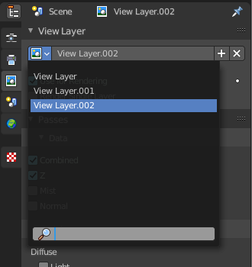
View Layers reference to Scene collections. They allow to set their visibility, selectability and other options. Each View Layer can use any collection you wish, and multiple View Layers can use the same collections or different collections.
Usually you have just one View layer for the whole scene. But you can create more View layers in the header, and rename them there.

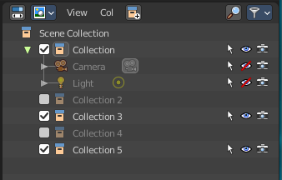
View layers are by default active for all collections. You can exclude them for specific layers in the Outliner. Select the view layer, and turn off the collections that you don't want to have active in this view layer.

Note. The different render engines uses different view layer functionality. And so the panels and available options differs.

View Layer Panel - All Renderers

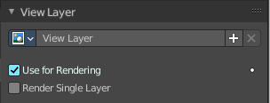
View Layer Prop

View Layer list
The list of available view layers

View Layer edit box
Set the active view layer, and view and edit the name of the current active view layer. Click into the edit box to edit the name.

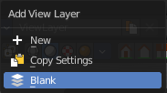
Add View Layer
Adds a new view layer.

New
Adds a new view layer with the default content.

Copy Settings
Adds a new view layer with the content of the current active layer.

Blank
Adds a new view layer and deactivates all collections.

Remove View Layer
Removes the selected view layer.

Use for Rendering
Disable or enable the render layer.

Animate Property
This property can be animated. Activating this button sets a keyframe at the current frame.

Render Single Layer
Only render the active layer. This just works for rendering from the interface. Rendering from command line ignores this setting.

Eevee - Passes panel

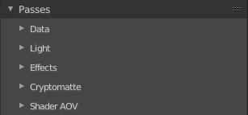
Here you enable or disable passes for single features.

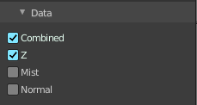
Data subpanel

Combined
Deliver full combined RGBA Buffer.

Z
Deliver Z Value pass.

Mist
Deliver Mist factor pass. 0.0 to 1.0

Normal
Deliver Normal pass.

Mist subpanel
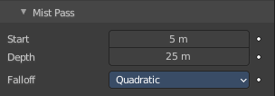
When you activate Mist pass, then the Mist Pass subpanel shows.

Start
The starting distance of the mist, measured from the camera.

Depth
The distance over which the mist effect fades in.

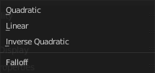
Falloff
The falloff progression of the mist.

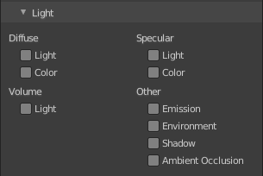
Light subpanel

Diffuse

Light
Deliver diffuse direct pass.

Color
Deliver diffuse color pass.

Specular

Light
Deliver specular direct pass.

Color
Deliver specular color pass.

Volume

Light
Deliver volume direct light pass.

Scatter
Deliver volume scattering pass.

Other

Emission
Deliver emission pass.

Environment
Deliver environment lighting pass.

Shadow
Deliver shadow pass.

Ambient Occlusion
Deliver Ambient Occlusion pass. Ambient Occlusion needs to be enabled in the Render Properties.

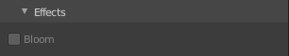
Effects subpanel
Deliver Bloom pass. Bloom must be enabled in the Render Properties.

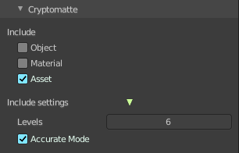
Cryptomatte subpanel
Cryptomatte passes can be used to isolate objects or materials or assets in compositing.

Include

Object
Render Cryptomatte Object Pass.

Materials
Render Cryptomatte Materials Pass.

Asset
Render Cryptomatte Asset Pass.

Include Settings
These settings appears when you tick one of the above includes.

Levels
How many unique objects can be distinguished per pixel.

Accurate Mode
Generate a more accurate cryptomatte pass. This feature renders at the CPU only, and consumes more memory.

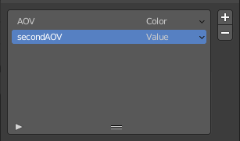
Shader AOV subpanel
AOV stands for Arbitrary Output Variables. Here you can add custom render passes for arbitrary shader node components. These values can then be used in the post processing in the node editor.
To use Shader AOVs create the pass in the Shader AOV panel then reference this pass with the AOV Output shading node. Each AOV in the list consists of a Name and Data Type.

List of AOV

Name
The name of the render pass. This is the Name that is referenced in the AOV Output node. You can name it as you like as long as the name does not conflict with enabled built-in passes.

Data Type
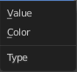
Right clicking at the black triangle at the end will refveal the type menu.
Shader AOVs can either express a Color or a Value variable. The Color variable as the name suggest can be used for a color but also a normal value. A Value variable can be used for any single numerical value.

Add AOV
Adds an AOV to the list.

Remove AOV
Removes the selected AOV from the list.

Cycles - Passes Panel
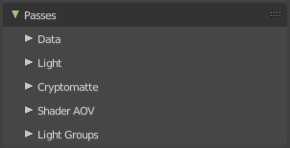

Here you enable or disable render passes for single features.

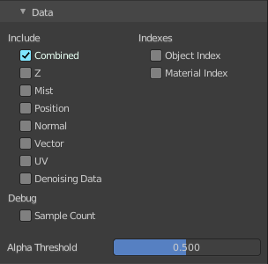
Data subpanel

Include

Combined
Deliver full combined RGBA Buffer.

Z
Deliver Z Value pass.

Mist
Deliver Mist factor pass. 0.0 - 1.0.

Normal
Deliver Normal pass.

Vector
Deliver Speed Vector pass.

UV
Deliver UV pass.

Denoising Data
Store the denoising feature passes and the noisy image.

Indexes

Object Index
Deliver Object Index pass.

Material Index
Deliver Material Index pass.

Debug

Sample Count
Number of samples/camera rays per pixel.

Alpha Threshold
Z, Index, Normal, UV and Vector passes are just affected by surfaces with alpha transparency equal or higher this threshold.

Mist subpanel
When you activate Mist pass, then the Mist Pass subpanel shows.

Start
The starting distance of the mist, measured from the camera.

Depth
The distance over which the mist effect fades in.

Falloff
The falloff progression of the mist.

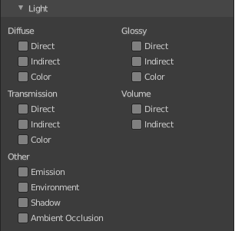
Light subpanel

Diffuse

Direct
Deliver direct pass.

Indirect
Deliver indirect pass.

Color
Deliver color pass.

Glossy

Direct
Deliver direct pass.

Indirect
Deliver indirect pass.

Color
Deliver color pass.

Transmission

Direct
Deliver direct pass.

Indirect
Deliver indirect pass.

Color
Deliver color pass.

Volume

Direct
Deliver direct pass.

Indirect
Deliver indirect pass.

Color
Deliver color pass.

Other

Emission
Deliver Emission pass.

Environment
Deliver Environment pass.

Shadow
Deliver Shadow pass.

Ambient Occlusion
Deliver Ambient Occlusion pass.

Cryptomatte subpanel
Cryptomatte passes can be used to isolate objects or materials or assets in compositing.

Include

Object
Render Cryptomatte Object Pass.

Materials
Render Cryptomatte Materials Pass.

Asset
Render Cryptomatte Asset Pass.

Include Settings
These settings appears when you tick one of the above includes.

Levels
How many unique objects can be distinguished per pixel.

Accurate Mode
Generate a more accurate cryptomatte pass. This feature renders at the CPU only, and consumes more memory.

Shader AOV subpanel
AOV stands for Arbitrary Output Variables. Here you can add custom render passes for arbitrary shader node components. These values can then be used in the post processing in the node editor.
To use Shader AOVs create the pass in the Shader AOV panel then reference this pass with the AOV Output shading node. Each AOV in the list consists of a Name and Data Type.

List of AOV

Name
The name of the render pass. This is the Name that is referenced in the AOV Output node. You can name it as you like as long as the name does not conflict with enabled built-in passes.

Data Type
Right clicking at the black triangle at the end will refveal the type menu.
Shader AOVs can either express a Color or a Value variable. The Color variable as the name suggest can be used for a color but also a normal value. A Value variable can be used for any single numerical value.

Add AOV
Adds an AOV to the list.

Remove AOV
Removes the selected AOV from the list.

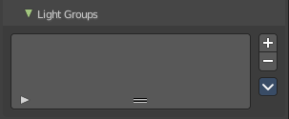
Light Groups subpanel
Light groups are a type of pass that only contains lighting from a subset of light sources. They are created in the View layer. And any light source (lamps, objects with emissive materials and/or the environment) can be assigned to such a group.
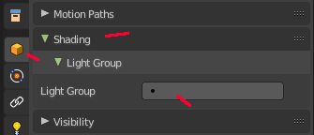
This can be done in the object properties in the shading panel.
Note that Light groups are identified by their name - therefore, the name of the Lightgroup in the View Layer and the name that's set in an object's settings must match for it to be included.

Add Light Group
Adds a new light group to the list.

Remove Light Group
Removes the selected lightgroup from the list.

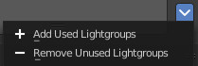
Lightgroup Sync menu

Add used Light groups
Add all used light groups to the list. It can be that there is an object attached to a light group which is not in the list yet. From an appended file for example.

Remove unused light groups
Removes all light groups from the list that has no user.

Cycles - Filter Panel
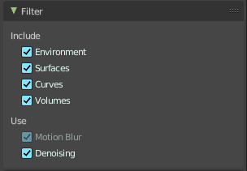

Include

Environment
Render Sky in this layer.

Ambient Occlusion
Render Ambient Occlusion in this layer.

Surfaces
Render solid surfaces in this layer.

Curves
Render Hair in this layer.

Volume
Render volumes in this layer.

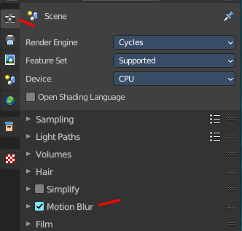
Use

Motion Blur
Render Motion Blur, if enabled in the scene.

Denoising
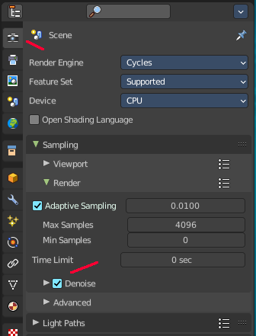
Use Denoising, if enabled in the scene.

Cycles - Override Panel
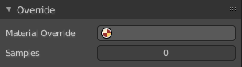
Here you can add a material that overrides all other materials in this layer. This allows clay renderings.

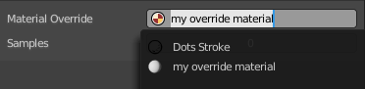
Material Override
Pick a material in the scene that should override all other materials.

Samples
Override number of render samples for this view layer. A value of 0 will use the scene setting values.

Freestyle Panel
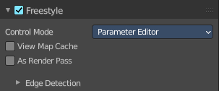
This panel and all further freestyle panels just shows when you have Freestyle activated in the Render Properties!

Enable
Enables or disables the freestyle layer in the current view layer.

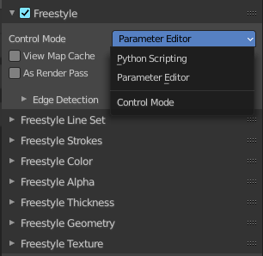
Control Mode
You can either control the freestyle shapes by the settings in the panels. Or you can use a python script to define all the shapes. In this case the panels vanishes, and you can add your style script below.
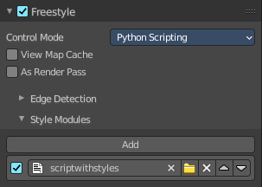

View Map Cache
Keep the computed Key Map. And avoid recalculation if mesh geometry is unchanged.

As Render Pass
Renders the freestyle pass as a separate pass instead of adding it as an overlay to the Combined pass.

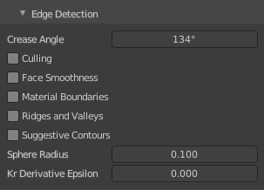
Edge detection subpanel
How the edge detection happens.

Crease Angle
Angular Threshold for detecting crease angles.

Culling
Ignore edges that are out of view.

Face Smoothness
Take the face smoothness into account for the view map calculation.

Material Boundaries
Use Material Boundaries.

Ridges and Valleys
Use ridges and valleys for the view map calculation.

Suggestive Contours
Use suggestive contours.

Sphere Radius
The sphere radius for calculating curvatures

Kr Derivate Epsilon
The Ki Derivate Epsilon radius for calculating suggestive contours.

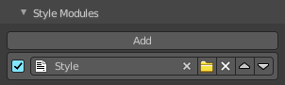
Style Module subpanel
This panel appears with Control Mode Python Scripting. Add a python script that defines the style.
The structure of such a style is not defined nor described. Please ask the Blender developers.

Freestyle Line Set Panel

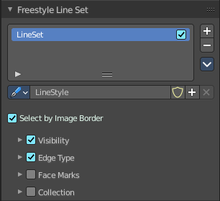
The line set settings.

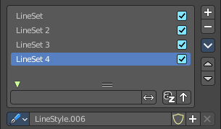
List of Line Sets
A line set holds the line style. You can have more than one line set. But just one LineStyle per set.
The line sets can be activated or deactivated with the checkbox at the end.

Drag Handler
Allows to resize the list.

Search field
When you click at the triangle button then you can reveal a search field.

Edit Box
Tpye in the search term and hit enter.

Invert
Inverts the search.

Sort by Name
Sorts the list by name

Reverse
Reverts the list content.

Add Line Set
Adds a new line set. Adding a new line set also adds a new LineStyle.

Remove Line Set
Removes the selected line set.

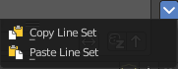
Lineset Specials menu

Copy Line Set
Copies the currently selected line set and all its settings.

Paste Line Set
Pastes the copied line set and all its settings into the currently selected line set.

Move Line Set up or down
Moves the selected up or down in the list.

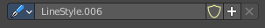
Line style data property

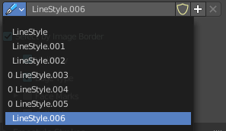
Data Browser
A list of available LineStyles.

Edit Box
Displays the name of the currently active LineStyle. It also allows you to rename the LineStyle. Click into the edit box, change the name, hit enter.

Fake User
Save this LineStyle with the scene even when it has no user. Fake User is an old Blender concept to keep data in the scene that has no user. Data without an user gets usually deleted with saving the scene.

Add new LineStyle
Adds a new LineStyle.

Remove LineStyle
This button is dysfunctional and permanently greyed out. Once added LineStyles are permanent by Blender design since every line set needs at least one linestyle. You can only remove unused linestyles by purging unused Data in the outliner.

Select by Image Border
Select feature edges by image border.

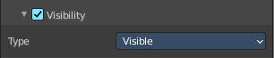
Visibility Subpanel
Determine how to use visibility for feature edge detection.

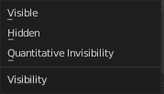
Type

Visible
Select visible feature edges.

Hidden
Select hidden feature edges.

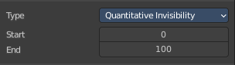
Quantitative invisibility
Select feature edges within a range of quantitative invisibility values. The value is called QI.

Start
The first value.

End
The last value.

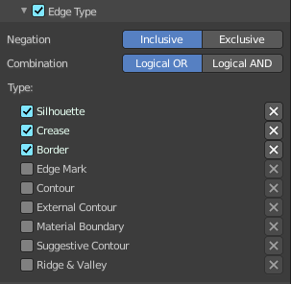
Edge Type subpanel

Selection by Edge Types
The checkbox in the header activates or deactivates the feature. Select feature edges based on Edge Types.

Negation

Inclusive
Select edges by satisfying the selected options.

Exclusive
Select edges by satisfying the exact opposite of the selected options.

Combination

Logical Or
Select edges by satisfying at least of the selected options.

Logical And
Select edges by satisfying all of the selected options.

Type
What type to use. The names should be self explaining. The X Button at the end is to exclude this type instead of including it.

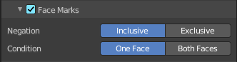
Face Masks Subpanel

Selection by Face Marks
Select Feature Edges by Face Marks.

Negation
Include or exclude the edges selected by face marks.

Condition
Select a feature edge if one face is marked. Or select a feature edge if the two adjacent faces are marked.

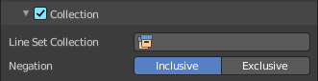
Collection Subpanel

Selection by Collection
Select feature edges based on a collection of objects.

Line Set Collection
Pick the collection that you want to use.

Negation
Select feature edges by including or excluding the selected collection.

Freestyle Strokes Panel
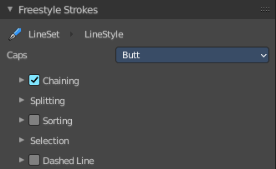

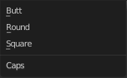
Caps
Select the shape of both ends of the stroke. Butt, Round or Square.

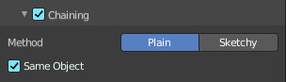
Chaining Subpanel

Chaining
Enable chaining of feature edges.

Method
How feature edges are jointed to form chains.

Plain
Feature edges are jointed plain.

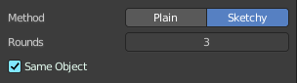
Sketchy
Feature edges are jointed sketchy.

Rounds
Number of rounds in a sketchy multiple touch.

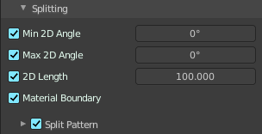
Splitting subpanel

Min 2D Angle
Minimum 2d angle for splitting chains.

Max 2D Angle
Maximum 2d angle for splitting chains.

2D Length
Curvilinear length for 2d splitting

Material Boundary
Split chains of feature edges at material boundaries.

Split Pattern sub subpanel

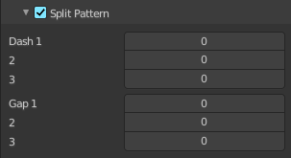
Use Split Pattern
Enable chain splitting by dashed line patterns.

Dash 1, 2, 3
Length of the dashes for splitting.

Gap 1, 2, 3
Length of the gaps for splitting.

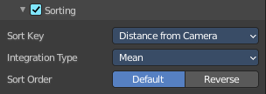
Sorting subpanel

Sort Key
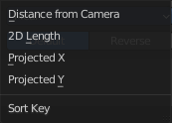
How to determine the stacking order of chains.

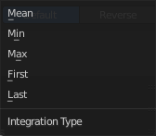
Integration Type
How the sort key is computed for each chain.

Sort order
Sort by default or inverse.

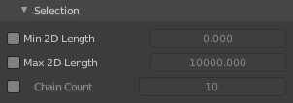
Selection Subpanel

Min 2D Length
The selection of chains by a minimum 2D length.

Max 2D Length
The selection of chains by a maximum 2D length.

Chain Count
Select first N chains. N stands for a variable, and is defined in the edit box.

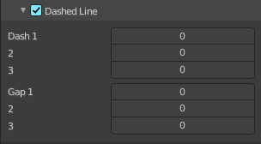
Dashed Line subpanel

Dashed Line
Enable dashed line. A line is then displayed as dashes.

Dash 1, 2, 3
Length of the dash for the dashed lines.

Gap 1, 2, 3
Length of the gap for the dashed lines.

Freestyle Modifiers

The Freestyle panels Freestyle Color, Freestyle Alpha, Freestyle Thickness and Freestyle Geometry allows you to use so called modifiers. Modifiers allows you to modify these settings in several aspects.
Some modifier, like the along stroke modifier, does have the same name. But has here and there different functionality.
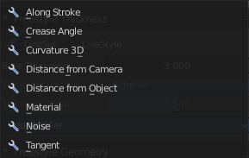
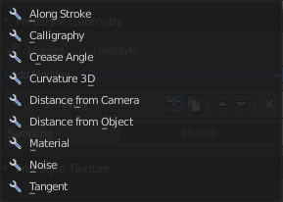
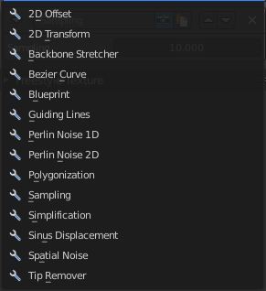

Color, Alpha and Thickness Modifier

Header
From left to right.

Triangle button
Open or close the modifier panel.

Edit Box
Displays the name of the modifier. You can also rename it. Click into the edit box, change name and hit enter.

Use
Enable the modifier.

Copy Modifier
Copies the Modifier.

Move Modifier
Moves the modifier up or down the list.

Remove Modifier
Removes the modifier from the list.

Color Ramp
The color, alpha and thickness modifiers all have a color ramp.

Controls

+
Add a stop to your color ramp. The stop will be added after the selected one, in the middle to the next one.

-
Deletes the selected color stop from the list.


Tools menu

Flip Color Ramp
Flips the gradient, inverting the values of the color ramp.

Distribute Stops from Left
Rearrange the stops so that every step has the same space to the right.

Distribute Stops Evenly
Space between all neighboring stops becomes equal.

Eyedropper (pipette icon) E
An Eyedropper to sample a color or gradient from the interface to be used in the color ramp.

Reset Color Ramp

Resets the color ramp to its default state.

Color Mode

RGB
Blends color by mixing each color channel and combining.

HSV/HSL
Blends colors by first converting to HSV or HSL, mixing, then combining again. This has the advantage of maintaining saturation between different hues, where RGB would de-saturate, this allows for a richer gradient.


Interpolation

Ease
Uses an Ease Interpolation for the color stops.

Cardinal
Uses a Cardinal Interpolation for the color stops.

Linear
Uses a Linear Interpolation for the color stops.

B-Spline
Uses a B-Spline Interpolation for the color stops.

Constant
Uses a Constant Interpolation for the color stops.

Color Ramp
The color band. A click at one of the color stops makes it the active one. You can move the color stops by clicking at them and dragging them around.

Active Color Stop elements
Adjust the active color stop.

Choose active color stop
Choose the color stop by index.

Number of Stop
The active color stop.

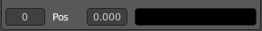
Pos
The position and color of the active color stop. The range goes from 0.000 to 1.000.

Freestyle Color panel
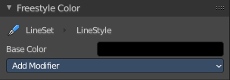
Modify the color of the stroke.

Base Color
Here you can choose the base color that needs to be modified.

Freestyle Color modifiers

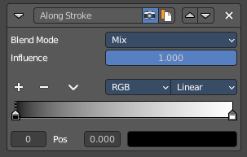
Along Stroke
Add a colorband along the stroke.

Blend Mode
The color blend mode.

Influence
The influence of the modifier.

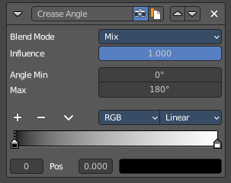
Crease Angle
Add a color band along a crease angle. Which is the angle between two adjacent faces) If a stroke segment does not lie on a crease , then its properties are not touched by the modifier.

Blend Mode
The color blend mode.

Influence
The influence of the modifier.

Angle Min / Max
The minimum and maximum crease angle to modify thickness.

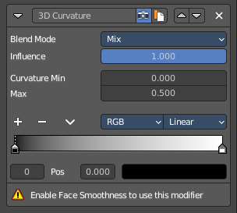
Curvature 3D
This modifier is based on the radial curvatures of the underlying 3D surface. The curvature of a 2D curve at a point is a measure of how quickly the curve turns at the point. The quicker the turn is, the larger the curvature is at the point. The curvature is zero if the curve is a straight line. Radial curvatures are those computed for a 2D curve that appears at the cross section between the 3D surface and a plane defined by the view point (camera location) and the normal direction of the surface at the point.
This modifier requires to have the Face Smoothness option on and the object needs to have Smooth Shading.

Blend Mode
The color blend mode.

Influence
The influence of the modifier.

Curvature Min and Max
The limits of the mapping. If the current point of the stroke is at Min Curvature or less from the target, it will take the start point of the mapping. If it is at Max Curvature or more from the target, it will take the end-point value of the mapping.

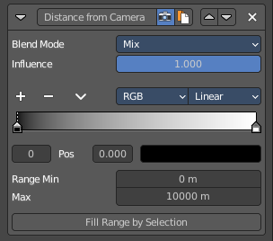
Distance from Camera
Recalculates the base property by the distance to the camera.

Blend Mode
The color blend mode.

Influence
The influence of the modifier.

Range Min and Range Max
The minimum and maximum range. These values are in scene units.

Fill Range by Selection
Sets the minimum and maximum range values from the distances between the current selected mesh vertices and the camera or the target.

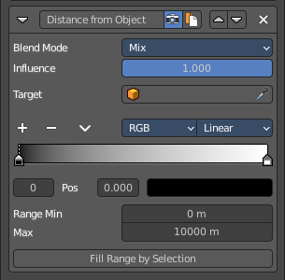
Distance from Object
Recalculates the base property by the distance to a chosen object.

Blend Mode
The color blend mode.

Influence
The influence of the modifier.

Target
Pick the target object.

Range Min and Range Max
The minimum and maximum range. These values are in scene units.

Fill Range by Selection
Sets the minimum and maximum range values from the distances between the current selected mesh vertices and the camera or the target.

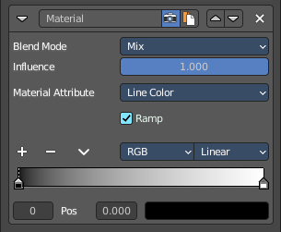
Material
Alters the base property on the current material under the stroke.

Blend Mode
The color blend mode.

Influence
The influence of the modifier.

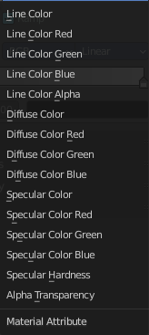
Material Attribute
What attribute of the material under the stroke to alter.

Ramp
Shows and activates the color ramp.

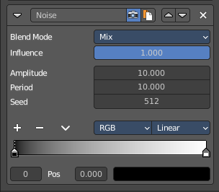
Noise
Uses a noise based pseudo random number generator to add some variation along the stroke.

Blend Mode
The color blend mode.

Influence
The influence of the modifier.

Amplitude
The maximum value of the noise. A higher amplitude means a less transparent (more solid) stroke.

Period
The period of the noise. This means how quickly the property value can change. A higher value means a more smoothly changing color along the stroke.

Seed
Seed used by the pseudo-random number generator.

Asymmetric
Thickness only – Allows the thickness to be distributed unevenly at every point.

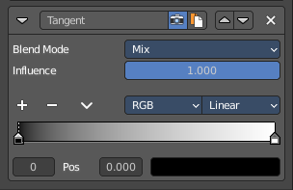
Tangent
Modifies the base value on the traveling direction of the stroke, evaluated at the stroke’s vertices.

Blend Mode
The color blend mode.

Influence
The influence of the modifier.

Freestyle Alpha panel
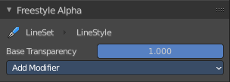
Modify the transparency of the stroke.

Base Transparency
The base transparency that you want to modify.

Freestyle Alpha modifiers

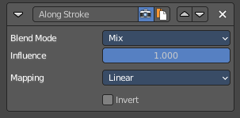
Along Stroke
Add a gradient along the stroke.

Blend Mode
The color blend mode.

Influence
The influence of the modifier.

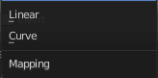
Mapping
The mapping type. Linear or Curve.

Invert
Inverts the values.

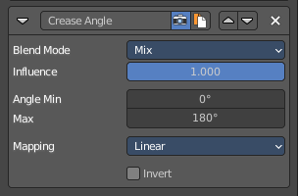
Crease Angle
Add a gradientalong a crease angle. Which is the angle between two adjacent faces) If a stroke segment does not lie on a crease , then its properties are not touched by the modifier.

Blend Mode
The color blend mode.

Influence
The influence of the modifier.

Angle Min / Max
The minimum and maximum crease angle to modify thickness.

Mapping
The mapping type. Linear or Curve.

Invert
Inverts the values.

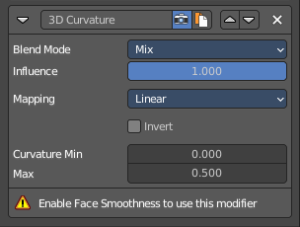
Curvature 3D
This modifier is based on the radial curvatures of the underlying 3D surface. The curvature of a 2D curve at a point is a measure of how quickly the curve turns at the point. The quicker the turn is, the larger the curvature is at the point. The curvature is zero if the curve is a straight line. Radial curvatures are those computed for a 2D curve that appears at the cross section between the 3D surface and a plane defined by the view point (camera location) and the normal direction of the surface at the point.
This modifier requires to have the Face Smoothness option on and the object needs to have Smooth Shading.

Blend Mode
The color blend mode.

Influence
The influence of the modifier.

Mapping
The mapping type. Linear or Curve.

Invert
Inverts the values.

Curvature Min and Max
The limits of the mapping. If the current point of the stroke is at Min Curvature or less from the target, it will take the start point of the mapping. If it is at Max Curvature or more from the target, it will take the end-point value of the mapping.

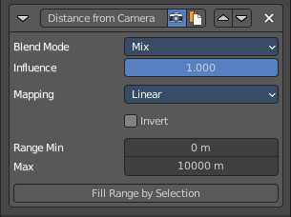
Distance from Camera
Recalculates the base property by the distance to the camera.

Blend Mode
The color blend mode.

Influence
The influence of the modifier.

Mapping
The mapping type. Linear or Curve.

Invert
Inverts the values.

Range Min and Range Max
The minimum and maximum range. These values are in scene units.

Fill Range by Selection
Sets the minimum and maximum range values from the distances between the current selected mesh vertices and the camera or the target.

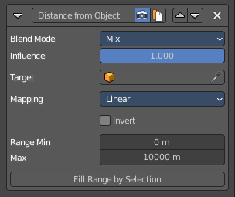
Distance from Object
Recalculates the base property by the distance to a chosen object.

Blend Mode
The color blend mode.

Influence
The influence of the modifier.

Target
Pick the target object.

Mapping
The mapping type. Linear or Curve.

Invert
Inverts the values.

Range Min and Range Max
The minimum and maximum range. These values are in scene units.

Fill Range by Selection
Sets the minimum and maximum range values from the distances between the current selected mesh vertices and the camera or the target.

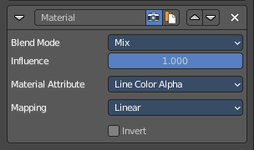
Material
Alters the base property on the current material under the stroke.

Blend Mode
The color blend mode.

Influence
The influence of the modifier.

Material Attribute
What attribute of the material under the stroke to alter.

Mapping
The mapping type. Linear or Curve.

Invert
Inverts the values.

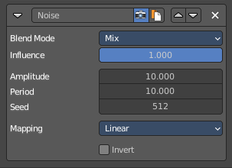
Noise
Uses a noise based pseudo random number generator to add some variation along the stroke.

Blend Mode
The color blend mode.

Influence
The influence of the modifier.

Amplitude
The maximum value of the noise. A higher amplitude means a less transparent (more solid) stroke.

Period
The period of the noise. This means how quickly the property value can change. A higher value means a more smoothly changing color along the stroke.

Seed
Seed used by the pseudo-random number generator.

Mapping
The mapping type. Linear or Curve.

Invert
Inverts the values.

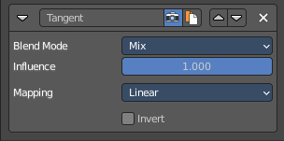
Tangent
Modifies the base value on the traveling direction of the stroke, evaluated at the stroke’s vertices.

Blend Mode
The color blend mode.

Influence
The influence of the modifier.

Mapping
The mapping type. Linear or Curve.

Invert
Inverts the values.

Freestyle Thickness panel
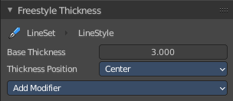
Modify the thickness of the stroke.

Base Thickness
The base thickness that you want to modify.

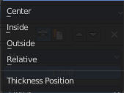
Thickness Position
The thickness position of silhouettes and border edges.

Center
Silhouettes and border edges are centered along the stroke.

Inside
Silhouettes and border edges are drawn inside of the stroke.

Outside
Silhouettes and border edges are drawn outside of the stroke.

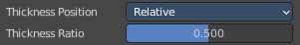
Relative
Silhouettes and border edges are shifted by a user defined thickness ratio.

Thickness Ratio
The thickness ratio to shift the silhouettes and border edges.

Freestyle Thickness modifiers

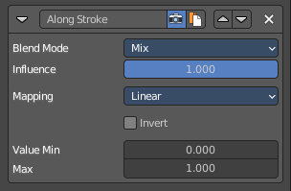
Along Stroke
Add a gradient along the stroke.

Blend Mode
The color blend mode.

Influence
The influence of the modifier.

Mapping
The mapping type. Linear or Curve.

Invert
Inverts the values.

Value Min / Max
Minimum and maximum output value.

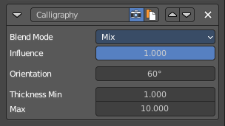
Calligraphy
Generates different thickness, based on the orientation of the stroke. The result is a stroke thickness that orients at calligraphy.

Blend Mode
The color blend mode.

Influence
The influence of the modifier.

Orientation
The angle of the virtual drawing tool, based at the vertical axis of the image. The thickest strokes will align with this angle.

Thickness Min / Max
Minimum and maximum output value.

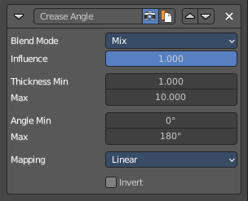
Crease Angle
Add a gradientalong a crease angle. Which is the angle between two adjacent faces) If a stroke segment does not lie on a crease , then its properties are not touched by the modifier.

Blend Mode
The color blend mode.

Influence
The influence of the modifier.

Thickness Min / Max
The minimum and maximum thickness.

Angle Min / Max
The minimum and maximum crease angle to modify thickness.

Mapping
The mapping type. Linear or Curve.

Invert
Inverts the values.

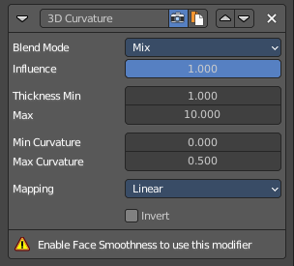
Curvature 3D
This modifier is based on the radial curvatures of the underlying 3D surface. The curvature of a 2D curve at a point is a measure of how quickly the curve turns at the point. The quicker the turn is, the larger the curvature is at the point. The curvature is zero if the curve is a straight line. Radial curvatures are those computed for a 2D curve that appears at the cross section between the 3D surface and a plane defined by the view point (camera location) and the normal direction of the surface at the point.
This modifier requires to have the Face Smoothness option on and the object needs to have Smooth Shading.

Blend Mode
The color blend mode.

Influence
The influence of the modifier.

Thickness Min / Max
The minimum and maximum thickness.

Curvature Min and Max
The limits of the mapping. If the current point of the stroke is at Min Curvature or less from the target, it will take the start point of the mapping. If it is at Max Curvature or more from the target, it will take the end-point value of the mapping.

Mapping
The mapping type. Linear or Curve.

Invert
Inverts the values.

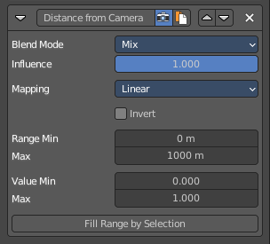
Distance from Camera
Recalculates the base property by the distance to the camera.

Blend Mode
The color blend mode.

Influence
The influence of the modifier.

Mapping
The mapping type. Linear or Curve.

Invert
Inverts the values.

Range Min and Range Max
The minimum and maximum range. These values are in scene units.

Value Min and Value Max
The minimum and maximum output value of the mapping. These values are in scene units.

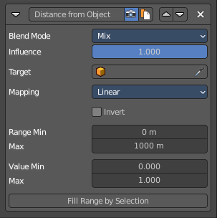
Distance from Object
Recalculates the base property by the distance to a chosen object.

Blend Mode
The color blend mode.

Influence
The influence of the modifier.

Target
Pick the target object.

Mapping
The mapping type. Linear or Curve.

Invert
Inverts the values.

Range Min and Range Max
The minimum and maximum range. These values are in scene units.

Value Min and Value Max
The minimum and maximum output value of the mapping. These values are in scene units.

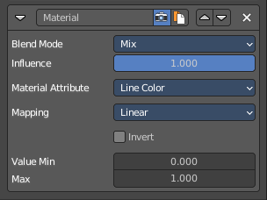
Material
Alters the thickness of the stroke based on the current material under the stroke.

Blend Mode
The color blend mode.

Influence
The influence of the modifier.

Material Attribute
What attribute of the material under the stroke to alter.

Mapping
The mapping type. Linear or Curve.

Invert
Inverts the values.

Value Min and Value Max
The minimum and maximum output value of the mapping. These values are in scene units.

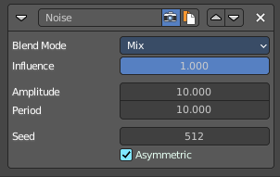
Noise
Uses a noise based pseudo random number generator to add some variation along the stroke.

Blend Mode
The color blend mode.

Influence
The influence of the modifier.

Amplitude
The maximum value of the noise. A higher amplitude means a less transparent (more solid) stroke.

Period
The period of the noise. This means how quickly the property value can change. A higher value means a more smoothly changing color along the stroke.

Seed
Seed used by the pseudo-random number generator.

Asymetric
Assign the thickness asymetrical at both sides of the stroke.

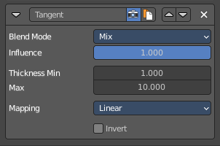
Tangent
Modifies the base value on the traveling direction of the stroke, evaluated at the stroke’s vertices.

Blend Mode
The color blend mode.

Influence
The influence of the modifier.

Thickness Min / Max
The minimum and maximum thickness.

Mapping
The mapping type. Linear or Curve.

Invert
Inverts the values.

Freestyle Geometry
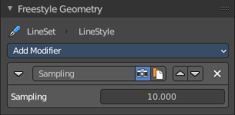
Modify the geometry of the freestyle strokes.
The modifier Sampling is on by default.

Freestyle Geometry Modifiers

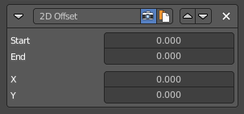
2D Offset
Offset the stroke vertices from its original position.

Start / End
The start and end of the offset relative to the stroke.

X / Y
The offset amount along X and Y axis of the stroke vertices.

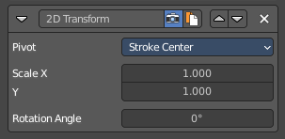
2D Transform
Scale the stroke.

Pivot
What center point to use for the scaling.

Scale X / Y
The scale amount along X and Y.

Rotation Angle
Rotate the stroke

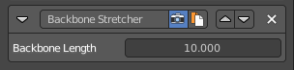
Backbone Stretcher
Stretch the stroke.

Backbone Length
Amount of backbone stretching.

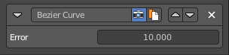
Bezier Curve
Turn the stroke into a bezier curve.

Error
The maximal allowed distance between the new bezier curve and the original backbone geometry.

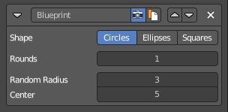
Blueprint
Turn the strokes into a blueprint/cad like style stroke.

Shape
The shape of the blueprint contour strokes.

Rounds
Number of rounds in contour strokes.

Random Radius
Randomness of the radius.

Center
Randomness of the center.

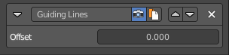
Guiding Lines
Replaces a stroke by straight lines that connects both of its ends.

Offset
Add an offset to the the start and end points along the original stroke, before generating the new straight one.

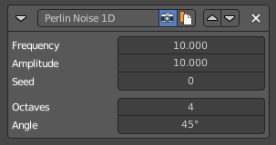
Perlin Noise 1D
Adds one-dimensional Perlin noise to the stroke. This modifier will give an identical result for two strokes with the same length and sampling interval.

Frequency
How dense the noise is (kind of a scale factor along the stroke).

Amplitude
How much the noise distorts the stroke in the Angle direction.

Seed
The seed of the random generator (the same seed over a stroke will always give the same result).

Octaves
The “level of detail” of the noise.

Angle
In which direction the noise is applied (0.0 is fully horizontal).

Perlin Noise 2D
Adds one-dimensional Perlin noise to the stroke. Different to the Perlin Noise 1D modifier the modifier generates noisy displacements using 2D coordinates of stroke vertices as the input of the noise generator.

Frequency
How dense the noise is (kind of a scale factor along the stroke).

Amplitude
How much the noise distorts the stroke in the Angle direction.

Seed
The seed of the random generator (the same seed over a stroke will always give the same result).

Octaves
The “level of detail” of the noise.

Angle
In which direction the noise is applied (0.0 is fully horizontal).

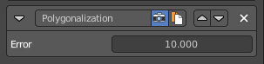
Polygonization
Simplify the stroke.

Error
The maximum distance allowed between the new simplified stroke and the orginal stroke.

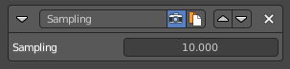
Sampling
Changes the definition and precision of the stroke for hte following modifiers.

Sampling
The smaller this value, the more precise are the strokes. The computation of smaller values needs more memory and time.

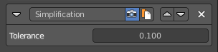
Simplification
Simplify the stroke by merging stroke vertices that are close to each other.

Tolerance
How close the vertices nees to be to each other to be merged.

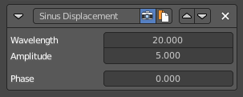
Sinus Displacement
Adds a sinusoidal displacement to the stroke.

Wavelength
How wide the undulations are along the stroke.

Amplitude
How high the undulations are across the stroke.

Phase
Allows “offsetting” (“moving”) the undulations along the stroke.
Tip! With a phase of 0 the undulations this modifier produces look exactly the same at a Phase of 0. Same goes for any positive or negative multiple of the Wavelength set on the modifier. This allows you to render short video sequences with wavy lines that can then be seamlessly looped without any visual jumps in the undulations along the line.

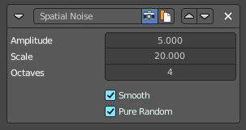
Spatial Noise
Adds some spatial noise to the stroke. Spatial noise displacements are added in the normal direction of each stroke vertex.

Amplitude
How much the noise distorts the stroke.

Scale
How wide the noise is along the stroke.

Octaves
The level of detail of the noise.

Smooth
When enabled, apply some smoothing over the generated noise.

Pure Random
The usual noise is not really random. Each value depends of the value before. So as a result is more a series of values. Which can lead to patterns. Pure random adds much more randomness to the strokes.

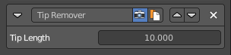
Tip remover
Removes a part of the stroke at the start and the end of a stroke

Tip Length
The length of the stroke that you want to remove.

Freestyle Texture

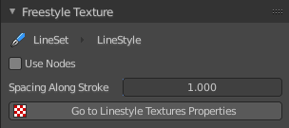
You can use a texture for the freestyle lines. The texture is created and managed in the texture tab. The material is created and managed in the Shader editor.
In this panel you just manage some settings for it

Use Nodes
Use shader nodes for the line style.

Spacing along Stroke
The spacing for textures along stroke length

Go to Linestyle Texture Properties
Switch to the Texture Properties tab to create and manage the texture.

Custom Properties Panel


Here you can define custom properties that can be used for scripting.

Here you might also find custom properties from addons or scripts.

Add
Adds a new property.


Edit
Opens a panel where you can adjust the settings for the custom property.

Remove
Removes the property.

